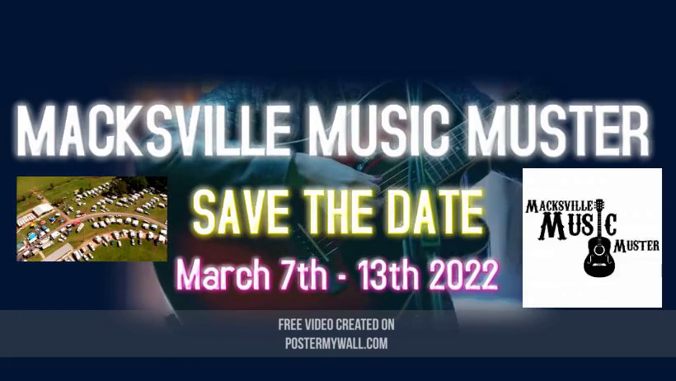
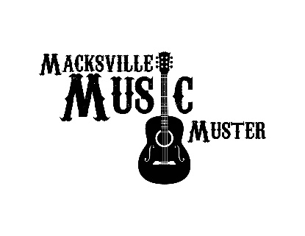
2020 - ARTIST APPLICATION & QUOTE ONLY – 10th – 13th MARCH 2022
CLOSES - 1st OCTOBER 2021
– Announcement of acceptance will be made on 1st December 2021
Name of Act: .......................................................................................
Contact person…………………………………………………………….
Phone…………………………………. Email…………………………………………….
(Please provide a link to at least one of the following that shows a live performance)
Web address (address) ..........................................................................
Facebook (address) ………………………………………………………….
YouTube (address) ………………………………………………………….
Instagram (address) ..............................................................................
Twitter (address) ....................................................................................
(Please attach & provide a current photo that can be used for advertisement purposes on flyers, posters and website– send to enquiries@macksvillemusicmuster.com.au )
Event you are applying for:
MACKSVILLE MUSIC MUSTER – MACKSVILLE SHOWGROUNDS
4 Spots (over the 3 days) Quote = …………………..
Do you require the Backing Band YES/NO (Please Circle)
Gospel Section – 2 or 3 songs Optional participation
(Spots will be allocated by the Hirer upon receiving all applications. It is the discretion of the Hirer whom is selected to perform and how many spots)
Music Genre: ....‘COUNTRY,COUNTRY ROCK, BUSH BALLARDS‘
– No other Music Genre will be allowed to be performed
Artist/Band Members:
Name………………………………………………………….
Instrument/s....................................................................................................
Name………………………………………………………….
Instrument/s...................................................................................................
Name………………………………………………………….
Instrument/s...................................................................................................
Name………………………………………………………….
Instrument/s………………………………………………………………………………
Name………………………………………………………….
Instrument/s..........................................................................................................
Accomodation:
Artists will be responsible for arranging and paying for their own accommodation.
Free Camp Sites will be available for Artists
Do you require a Camp Site – YES/ NO (Please Circle)
Number of Artists........................
I have read and agree to the terms and conditions.
Artist
Name: …………………………………………………………………….
Signature: ...............................................................................
Signature of Parent or Guardian if Artist is under the age of 18 years.
Name: …………………………………………………………………….
Signature: ............................................................................... Date.........../............/...............
Applications must be signed and scanned back to enquiries@macksvillemusicmuster.com.au
or posted to ARTIST CO-ORDINATOR – Vanessa Sanger
44 Hayes Road, Lower Wonga QLD 4508

