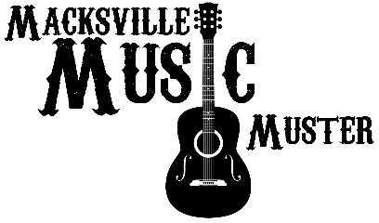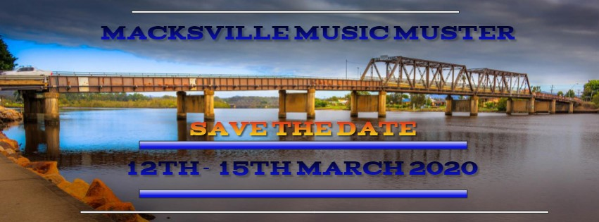

Invitation to apply for the
Macksville Music Muster as a Food/Trade Stall/s

………………MACKSVILLE SHOWGROUNDS – MID NORTH COAST…………………
The Macksville Music Muster
will feature 3 and a half days of Country Music Entertainment.

Featuring Walk Ups, Bush Poets, Local & Interstate Country Music Artists

Macksville Music Muster will be a:
- Ticketed Event
- Variety of LIVE Local Country Music Artists PLUS a Headline Act for Main Show
- Variety of Food Truck & Stalls.
- Family FUN DAY – Saturday – Rides, Stalls, Bush Dance
- Bring your own Chairs, Umbrella’s, Marquee’s, Rug, Eskys
- Auctions, Raffles
- Powered and Non-Powered Camping Sites

We would like to invite you to apply to attend as a Food or Non-Food Vendor for the Macksville Music Muster 12th - 15st March 2020
Please fill in the application form and return via email to Stall Holder Co-Ordinator Tina Midson
tinamidson@gmail.com – Closes on the 1st December 2019
This application is to trade from 12th to the 15th March 2020.

An application does not ensure automatic entry.
The Organiser reserves the right to accept or decline any booking application.
On acceptance, all details regarding your site will be sent to you prior to the event.
These details will also detail all site information, bump in and bump out times, event programme

FOOD/STALL APPLICATION FORM:
Company Name:……………………………………………………………………………………….
Trading Name:………………………………………………………………………………………….
ABN:…………………………………………………………………………………………………………
Contact Name:…………………………………………………………………………………………
Phone:……………………………………………………………………………………………………..
Mobile:……………………………………………………………………………………………………
Email:………………………………………………………………………………………………………
Postal Address:………………………………………………………………………………………..
Website:………………………………………………………………………………………………….
Social Media:…………………………………………………………………………………………..

SITE SIZE REQUIRED (please tick box):

3 DAY BOOKING
- 4M x 4M Standard Food SITE – $100.00 FOR WHOLE 3 DAYS - Includes two Entry tickets to the Muster, Vehicle Parking Space near Food Stall.
- 6M x 4M Deluxe Food SITE - $175.00 FOR WHOLE 3 DAYS - Includes two Entry Tickets to the Muster, Vehicle Parking Space near Food Stall.
- 6M x 6M Grand Food SITE - $300.00 FOR WHOLE 3 DAYS - Includes two Entry Tickets to the Muster, Vehicle Parking Space near Food Stall.

DAILY RATE BOOKING
- 4M x 4M Standard Food SITE – $35 PER DAY - Includes two Entry tickets to the Muster, Vehicle Parking Space near Food Stall.
PLEASE NOMINATE WHICH DAYS
WEDNESDAY – THURSDAY – FRIDAY – SATRUDAY
- 6M x 4M Deluxe Food SITE - $75 PER DAY - Includes two Entry Tickets to the Muster, Vehicle Parking Space near Food Stall.
PLEASE NOMINATE WHICH DAYS
WEDNESDAY – THURSDAY – FRIDAY – SATRUDAY
- 6M x 6M Grand Food SITE - $110.00 PER DAY - Includes two Entry Tickets to the Muster, Vehicle Parking Space near Food Stall.
PLEASE NOMINATE WHICH DAYS
WEDNESDAY – THURSDAY – FRIDAY - SATRUDAY
- 4M x 4M Standard SITE – $25.00 PER DAY Includes two Entry tickets to the Muster, Vehicle Parking Space near Food Stall.
- 8M x 4M DOUBLE SITE – $50.00 PER DAY Includes two Entry tickets to the Muster, Vehicle Parking Space near Food Stall.
- Kids Rides - $100.00 per amusement per day
PLEASE INDICATE NUMBER OF AMUSEMENTS
____________________________________

STALL HOLDERS - PRODUCTS YOU WISH TO SELL at MACKSVILLE MUSIC MUSTER
Please list or attach the type of cuisine, menu, and any alternative dietary options such as vegan or vegetarian to be sold on the event days. Also include any allergy sensitive foods that may be on the menu. If you have an unauthorised product, we may ask you to stop selling it on the day.

NOTE: We aim to keep the products varied to avoid the same products being sold by multiple vendors, it is important to get your full menu list with this application. In this respect it is vital that you are clear as to what you are selling. We will make our decisions based on this information provided.

INSURANCE:
Do you hold Product/Public Liability insurance? YES / NO
If yes, please state the amount you are insured for, and include the insurance company name and policy number as well as a copy of the certificate of currency: (min: $10million)
Insurance company:

Policy number:

Amount insured:

Do you hold Workers Compensation Insurance? YES / NO If yes, please attach a copy of the insurance.
Do you hold a Food Handling Certificate? YES / NO If yes, please attach a copy of the certificate.

ELECTRICAL:
What powered equipment are you bringing and number of each? Attach separately if more space needed.
Note: External/Portable generators will be permitted on site. Appliance x # Dimensions Amps Plug Type

LOCATION:
Positioning is at the discretion of the Event Organiser and will consider maximising the flow of patrons for ALL stallholders.
The Stall Holders will be situated around the Muster ensuring a high foot traffic area and will feature a range of quality food, beverage and market stalls.

We expect to attract between 200 – 1000+ people.

PROMOTIONAL ACTIVITY:
Stall Promotions
Flyers, signage and any promotions such as giveaways must be approved in writing by the Event Organising Committee. If you have any such requests, please make sure you list them here.
All giveaways and stall promotions must be done from within your allocated space.

MARKETING OPPORTUNITIES:
Event Programme Advertising
The festival programme will have a 50-word listing available to include your name and logo. This program will be available on the events website as well as flyers and any other promotional material.
Please write out your wording and email a copy of your logo to
enquiries@macksvillemusicmuster.com.au

STAFF LIST:
Please list Full Names of all Staff (title, first name and surname) for stallholder entry Person 1
Person 2

Extra Staff
If additional staff tickets are required, state the number below and it will be at the discretion of the Organisers

Person 3

Person 4

Person 5

Person 6
PAYMENT OPTIONS:
Upon confirmation of your stall being accepted to the Macksville Music Muster Invoices will be sent out. Please make payment using one of the following options. Payment must be received within 7 days of being accepted as a stall holder to secure your position. If no payment is received for your stall fee, the site will be given to another stall holder.
Payment Method (please tick payment method)
- Direct debit payment
- Credit Card (MasterCard or Visa) Card Holders Name

Card Number

Expiry Date / CCV No. (Appears on the back of the card)

Signature Amount $

Please reference your name and stall name on the bank deposit form.
Please send remittance for payments made to: enquiries@macksvillemusicmuster.com.au

TERMS AND CONDITIONS FOR STALLHOLDERS

  - The allocation of a market site is at the discretion of the Hirer. Ownership, possession and control of sites is held by the Hirer always.
  - Market sites are not guaranteed, and this agreement is not transferrable.
  - Stallholders are to ensure that their site is always attended, presentable, professional and safe and all displays are contained within the set site parameters.
  - Stallholders must leave their site in a clean state and all waste must be removed from the site.
  - Stallholders must not dispose of grey water on site or dispose of any plastic or cardboard packaging at the event.
  - Sites must be ready to trade from 9am on the day of the event
  - Cancellation/Absences from the Event must be in writing to the Event Organisers no later than 5 Business days prior to the event. A Full Refund of Fees will be given to the Stall Holder if notified within this period. Any notification less than 5 business days prior to the event will result in a 50% refund.
  - If no notification of Cancellation or Absence is received by the Event Organiser full fees will be kept.
  - Stallholders are required to attend their site in all weather conditions and only Organoids of the event can announce a cancellation of the market should the weather conditions become unsafe. This will be done at least 48hrs prior to the commencement of the event and Full Fees paid will be refunded to the Stallholder.

RENTS AND FEES
  - Invoices will be emails and Stall Fees are to be paid in FULL 14 days prior to the Event - may be made by cash, cheque, eftpos or by direct deposit quoting the stallholder’s last name as the reference.
  - A Stallholder will not be permitted to attend unless payment is made in Full 14 days prior to
the commencement of the Event.

INSURANCES, LICENCES AND REGISTRATIONS
  - All stallholders must have current Public and Product Liability Insurance for minimum of
$10M, a copy of which must be provided to Organiser upon payment and acceptance, prior to the stallholder commencing trade.
  - Food stalls must display a current Food Business Licence and the stallholder must have completed a food safety supervisor’s certificate course.
  - All food stalls must fully comply with food, health and safety standards and must ensure the health and safety of their customers and fellow stallholders.
  - All electrical and gas equipment must be regularly maintained and have current testing tags attached as required by law.

VEHICLES AND PARKING
  - Stallholders will have one extra parking spaces close to their stall site allocated.
  - All other vehicles must park in the general parking area.

GENERAL CONDITIONS
  - Stallholders are to represent themselves and the market in a professional, safe and courteous manner and to not engage in behaviour that brings the reputation of the Organiser of event into disrepute.
  - Stallholders shall comply with reasonable directives by the Organiser.
  - No smoking or dogs (except guide dogs) are permitted within stalls or on market grounds.
  - In case of an emergency, stallholders are to comply with organisers authorised staff directions.
  - Occupational health and safety is the personal responsibility of stallholders to protect their own and others’ safety.
We accept all Terms & Conditions Signature of Applicant

Date / /

