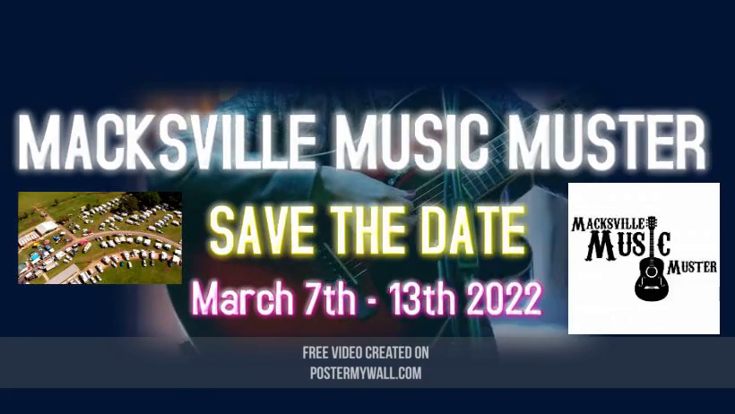
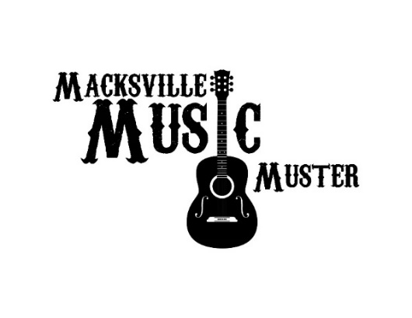
The Inaugural

To Previous & Prospective Local Businesses and Supporters of the Annual Macksville Music Muster.

If you were a founding sponsor of the Inaugural Macksville Music Muster, we again say a huge thank you for being involved in helping to make the event such a success. We welcome you, to again sponsor the 2022 Macksville Music Muster which is to be held on the 7th – 13th March 2022 at the Macksville Showground. With the annual Macksville Music Muster, our aim is to have an event that brings visitors from all over Australia to enjoy fantastic music but also experience, visit and support our beautiful Nambucca Valley.
Vanessa Sanger had a vision to bring country music back to the Valley to support the area in which she grew up in. This was successfully achieved in 2019, 2020 and with your help, the 2022 will be BIGGER and BETTER. We are proud to say that our aim is to ‘Keep It Simple, Keep It Country’ – with a back to basics approach. The Macksville Music Muster is a 3 ½ day event which features quality musicians, artists, food and market stalls. Our aim is to support the local stall holders and business first and foremost.
At the 2019 & 2020 Muster, these visitors spent their time and money in our local businesses and the feedback was incredibly positive. We envisage that this will grow to nearly double the attendees from those years and promote even more spending in the Valley.
We plan to continue to cover a wide variety of country music, including some of the best local talent we have here in the Nambucca Valley.
Our aim each year continues to see the proceeds from the profits of the Muster to go back to the community. We will be looking for a Charity for 2022.
Sponsorship, of course is massive key to the success of the Macksville Music Muster 2022. With your support, we will be able to secure a high-quality event attracting an increase in visitors each year.
We have put together a range of sponsorship packages and we are confident that one will match your sponsorship budget and you will be happy to commit to becoming on board as a sponsor of the Macksville Music Muster 2022.
Sponsorship Applications are open, and we need more help – if we do not receive enough support from the local community, we will have to reconsider the event in its entirety.
We again would like to show our appreciation for the support received in 2019 & 2020. If you would like more information or clarification, please contact:
Vanessa Sanger -
Macksville Music Muster Co-ordinator
0402 512 116
enquiries@macksvillemusicmuster.com.au
Thank you for your time. Looking forward to hearing from you.

EXPRESSION OF INTEREST FOR SPONSORSHIP NOW OPEN FOR 2022
3 and a Half days of Country Music Entertainment.
Featuring Walk Ups, Bush Poets, Local & Interstate Country Music Artists
Macksville Music Muster will be a:
- Paid Ticketed Only Event
- Variety of LIVE Local Country Music Artists PLUS other up and coming Country Artists from around Australia
- Variety of Food Truck & Stalls.
- Family Friendly Fun Day Saturday
- Bring your own Chairs, Umbrella’s, Marquee’s, Rug
- Outside Food and Drinks will be allowed.

Sponsorship packages for 2022 are now available, and we invite you to consider the various options.
GOLD: $1000
What you will receive:
- 10 Free Entry Tickets.
- Certificate of Appreciation
- Prominent Signage at the event (using your own promotional material)
- Advertising on all promotional media – Web, Newspapers, Radio, Flyers, Social Media.
- Logo placed in prominent position on all posters and program booklets.
- Trade Site space for products and services to be displayed.
- Mentions on Loudspeaker at regular intervals throughout the day.
- Link placed on our website advertising your business.

SILVER: $500
What you will receive:
- 5 Free Entry Tickets.
- Certificate of Appreciation
- Prominent Signage at the event (using your own promotional material)
- Advertising on all promotional media – Web, Newspapers, Radio, Flyers, Social Media
- Logo placed in prominent position on all posters and program booklets.
- Trade Site space for products and services to be displayed.
- Mentions on Loudspeaker at regular intervals throughout the day.
- Link placed on our website advertising your business.

BRONZE: $200
What you will receive:
- 2 Free Entry Tickets.
- Certificate of Appreciation
- Prominent Signage at the event (using your own promotional material)
- Advertising on all promotional media – Web, Newspapers, Radio, Flyers, Social Media
- Logo placed in prominent position on all posters and program booklets.
- Trade Site space for products and services to be displayed.
- Mentions on Loudspeaker at regular intervals throughout the day.
- Link placed on our website advertising your business.

THANK YOU FOR SUPPORTING THIS LOCAL EVENT

This is a Charity Event and if numbers are not supported the Muster will be cancelled 21 days prior to the Event Date.
If the Muster is cancelled a Full Refund will be provided for your Sponsorship package.
Invoices will be sent, and Sponsorship payment must be paid within 14 business dates of the Events Commencement.
For further information regarding Macksville Music Muster contact:

- Sponsorship Co-Ordinator Vanessa Sanger 0402 512 116

2022 EXPRESSION OF INTEREST FOR SPONSORSHIP

BUSINESS NAME: …………………………………………………………………..
CONTACT NAME: …………………………………………………………………..
PHONE: …………………………………………………………………………………
EMAIL: ………………………………………………………………………………….
ADDRESS: …………………………………………………………………………
……………………………………………………………………………………………..
……………………………………………………………………………………………..
We are interested in being a proud Sponsor of the 2020 Macksville Music Muster.
Signature: ………………………………………………………… Date: ………………………………..
(Please Circle package)
GOLD $1000 SILVER $500 BRONZE $200
We can supply:
LOGO: YES/NO WEBSITE LINK: ……………………………………………………..
BANNER: YES/NO TRADE STALL: YES/NO
