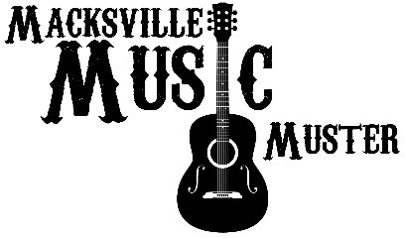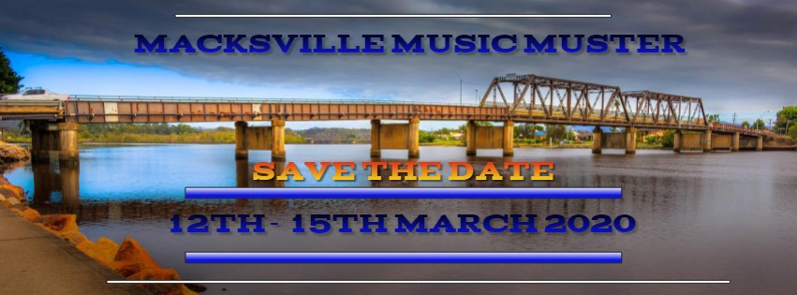

Invitation to apply for the
Macksville Music Muster as a VOLUNTEER

………………MACKSVILLE SHOWGROUNDS – MID NORTH COAST…………………
The Inaugural Macksville Music Muster
will feature 3 and a half days of Country Music Entertainment.

Featuring Walk Ups, Bush Poets, Local & Interstate Country Music Artists

Macksville Music Muster will be a:
- Ticketed Event
- Variety of LIVE Local & Interstate Country Music Artists
- Variety of Food Truck & Stalls.
- Family Friendly
- Bring your own Chairs, Umbrella’s, Marquee’s, Rug, Eskys
- Powered and Non-Powered Camping Sites

We would like to invite you to apply to attend as a Volunteer for the Macksville Music Muster 12th – 15th March 2019
Please fill in the application form and return via email to
enquiries@macksvillemusicmuster.com.au – Closes on the 1st December 2020

VOLUNTEER APPLICATION
An application does not ensure automatic entry.
The Organiser reserves the right to accept or decline any application.
On acceptance, all details regarding your role as Volunteer will be sent to you prior to the event. You will also receive a day pass for the day that you Volunteer ONLY! (Eg if you Voluteer to help over all three days you will get a pass for all 3 days – if you volunteer for only 1 day you will get a 1 day pass only.

Name:

Address:

Phone Number:

Email:

Have you Volunteered before – If so where and what was your
role:

Do you have any skills that will assist us in assigning you to a certain Volunteering
role?

Signature:

Date / /

